**The data shows that People fund their passions:** Theater, the most popular category, has the most cases of successful campaigns and concurrently the most cases of failed campaigns. This Category contains 3 Sub-categories, Musical, Plays, and Spaces. Of these 3 Sub-categories, Plays are far more popular than Musical and Spaces. Although Plays have roughly 6 times the failures of Musical and about 4 times than that of Spaces, Plays also has the lowest cancelation rate and boasts almost 5 times more successful campaigns than Musical and Spaces combined!

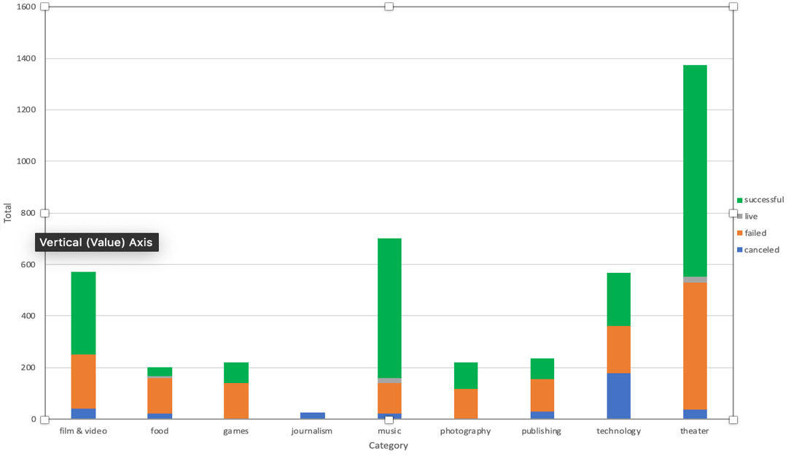

**Success can be found:** Music ranks in as the 2nd most popular category, but don’t let that fool you. Successful Music Campaigns outnumber those of Failed Campaigns by almost 5:1 (compared to Theater’s 2:1). However, all of Music’s Sub-categories do not bask in success. For example, World Music has a 100% Cancellation rate with no successes or failures. Sadly, Jazz has a 100% failure rate. Oddly, Faith has the most Live projects but also has a 100% failure rate. However, Classical, Electro, Metal, Pop, and Rock all have a 100% success rate.

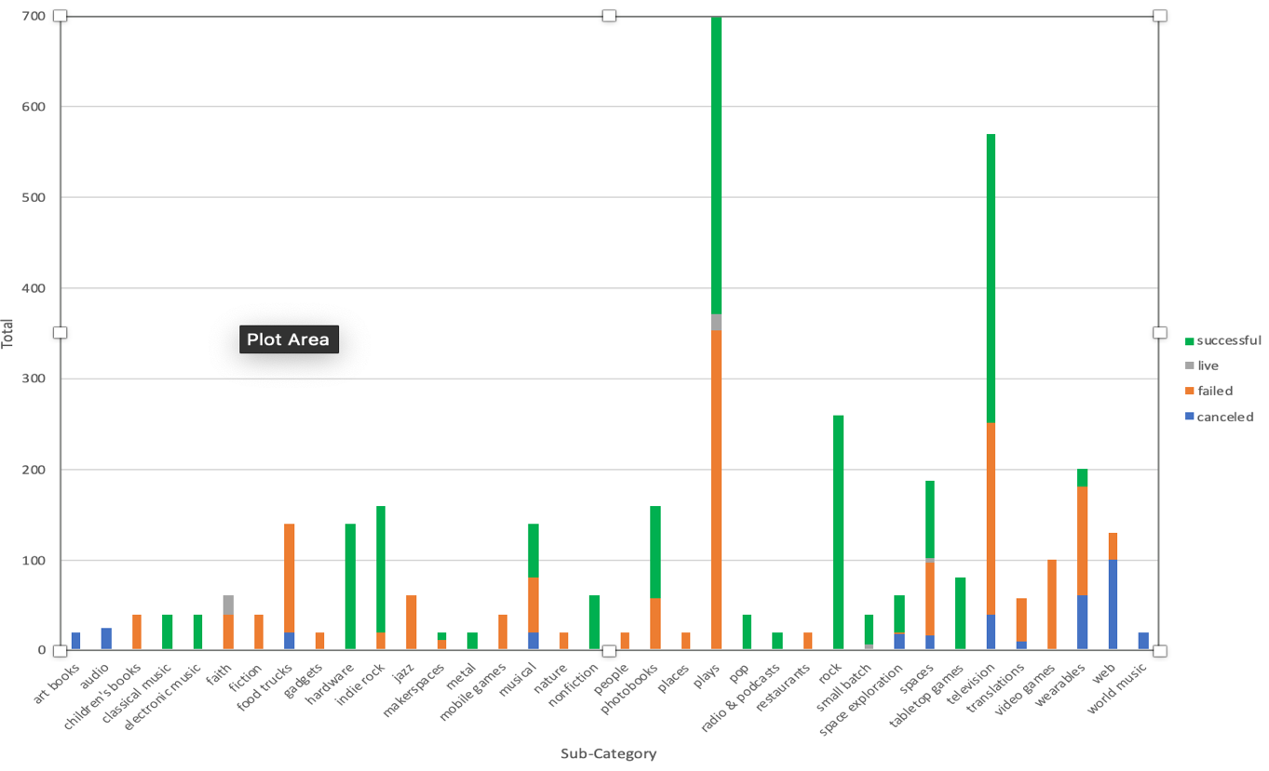

**Timing is important:** There was a huge upswing in activity on Kickstarter in 2014. The previous year only had 274 campaigns on record followed by a 3X jump in 2014 with 976 campaigns. 2015 was a banner year with 1,226 campaigns, that 4X growth in 2 years! Then there was a decrease in activity in 2016 with only 949 campaigns. This begs the questions “Is Kickstarter’s popularity fizzling out or, with the rise of other funding platforms, are people finding other ways to fund their passions?

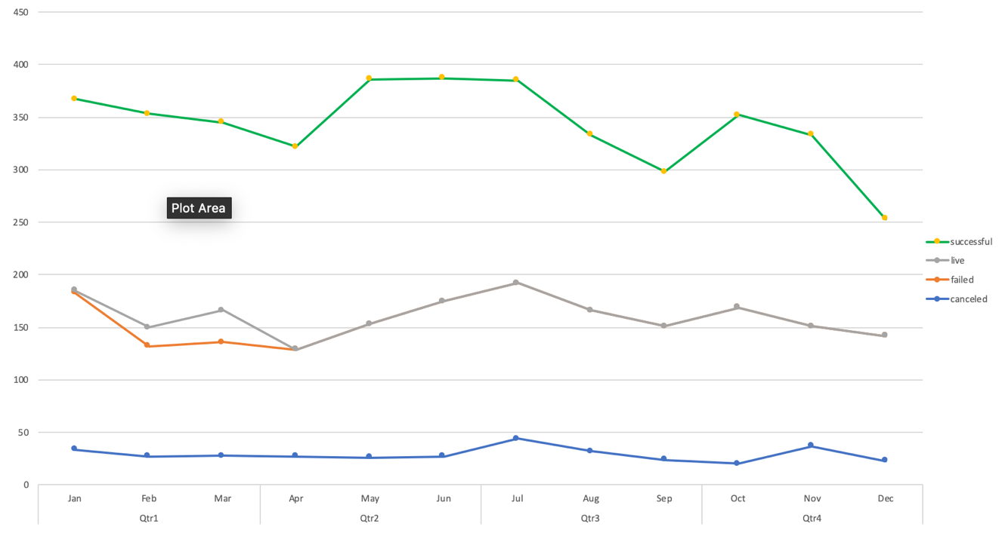

**What are some of the limitations of the Dataset?**

1. **The measure of success is limited to funding:** Though the data does tell us about the successes and failures of each funding campaign, it does not tell us if the actual projects were successful or not after reaching their funding goal.
2. **The factors that influence a campaign’s success or failure are not clear:** We found data that shows how popular certain categories are, however, the success and failures recorded in each category does not reveal why some found success, got canceled, or failed completely.
3. **The data does not show what parts of the country the campaigns originate or what areas have the highest number of supporters:** Does it matter where you are from? Does sharing the same hometown influence a supporter to pledge or not?

**What are other possible tables/graphs that we can create?**

1. We can create a bar graph that shows the results of Staff Picks vs Successful Campaigns to see if a campaign has a better chance of success if it is featured as a Staff Pick.
2. We can also create a pivot table to show which countries are have the most activity and which categories are most popular in those countries.
3. We use the pivot table we created that shows activity per quarter, per year and use that data to help predict the best time of the year to launch a campaign based on the overall pledges per quarter.